**My Portfolio Website**

**Name**: Micos Andrei L. Estrada  
**Year and Section**: 2024 - Computer Science Student

**Website Description**

**Brief Description of Your Website**:  
  
This is a personal portfolio website created to showcase the skills, projects, and background of Micos Estrada. The website introduces the owner with an engaging design, utilizing modern frontend technologies to create an interactive and visually appealing user experience. The website includes sections such as **Home**, **Skills**, **About**, **Projects**, and **Contact**. It also features animations, a responsive navigation bar, and social media links to enhance user interaction.

**Web Pages**:

1. **Home**: The homepage introduces the portfolio owner, Micos Estrada, with a short bio and interactive typewriter text effect. The homepage also includes a "Hire Me" button, leading to the user's contact or further information.
2. **Skills**: A page dedicated to displaying the technical skills of the owner, such as programming languages and tools.
3. **About**: Provides more detailed information about the owner’s background, education, and achievements.
4. **Projects**: Showcases various personal and professional projects the owner has worked on, demonstrating technical expertise.
5. **Contact**: A contact page with a form or contact details for potential employers or collaborators to reach out.

**Frontend Web Technologies Used**:

* **HTML**: The foundational structure of the website.
* **CSS**: Custom styles (via an external style.css file) for layout, colors, typography, and responsiveness.
* **JavaScript**: Used for interactive elements like the hamburger menu and for initializing animations.
* **Font Awesome**: For icons such as social media links and the hamburger menu.
* **AOS (Animate On Scroll)**: For scroll-triggered animations that enhance the user experience, such as fade-ins, zoom-outs, and flip effects.

**Discussion on Web Frameworks Added**: While the website does not use a full JavaScript framework (like React or Angular), it incorporates AOS for animation effects and Font Awesome for icons. The website also uses external resources like CDN links to integrate CSS and JS libraries, making the development process quicker and reducing the need for custom coding for these features.

**Overall Design**:  
The website is designed with a modern and clean aesthetic. It is fully responsive, making use of the hamburger menu on smaller screens and showcasing dynamic animations for engagement. The animations are powered by AOS, providing a polished and interactive experience for visitors.

**URL of the Website**

<https://cosmeboplagestrada.github.io/CosmeBoplagEstrada/>

**Screenshot of Website**

**HOME**

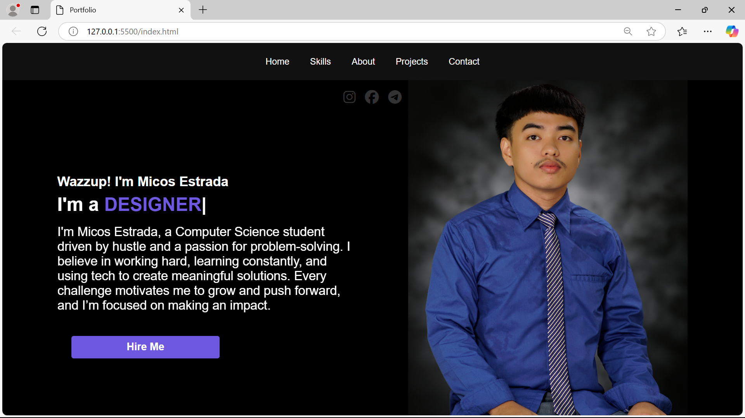

**SKILLS**

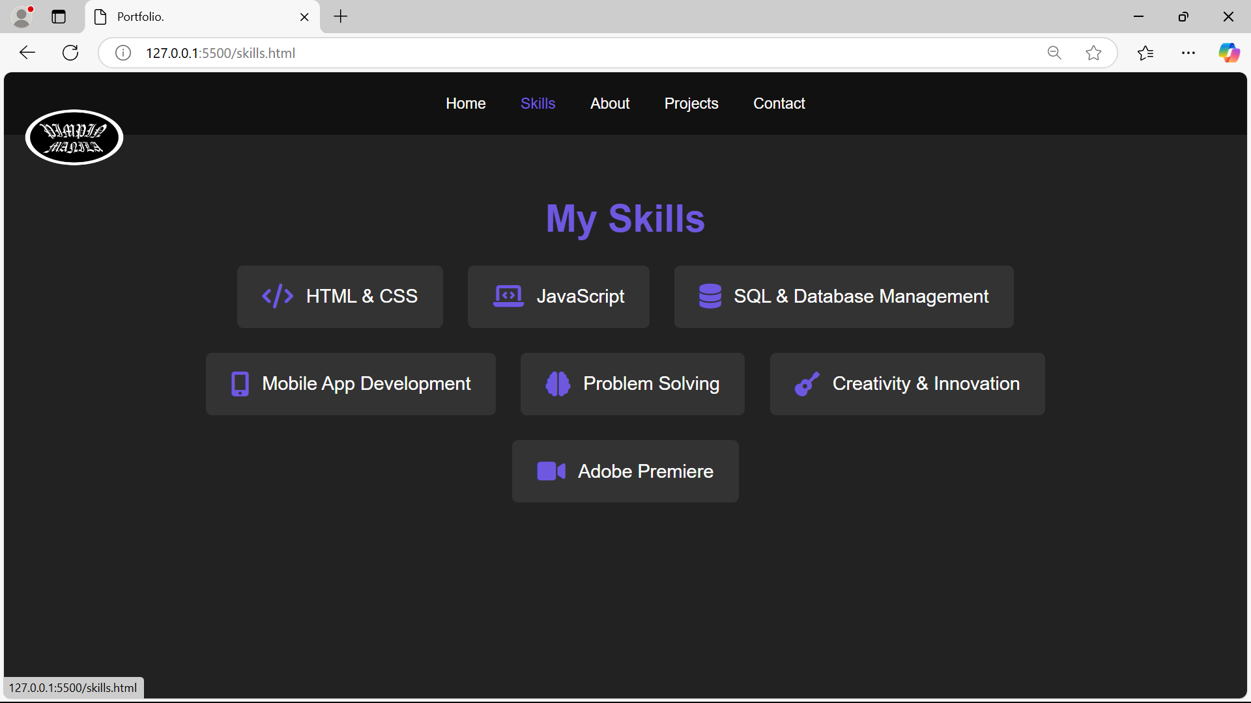

**ABOUT**

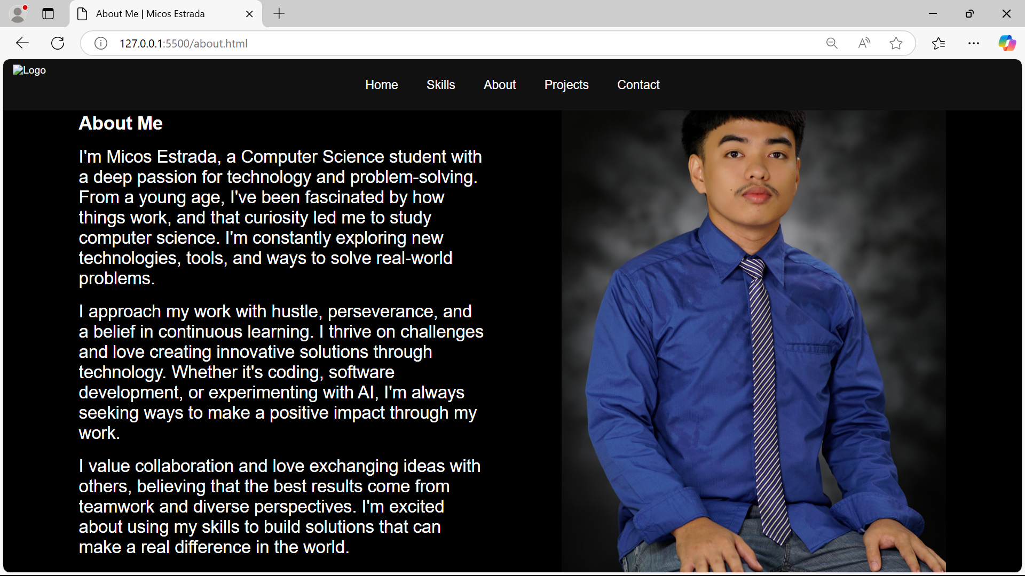

**PROJECTS**

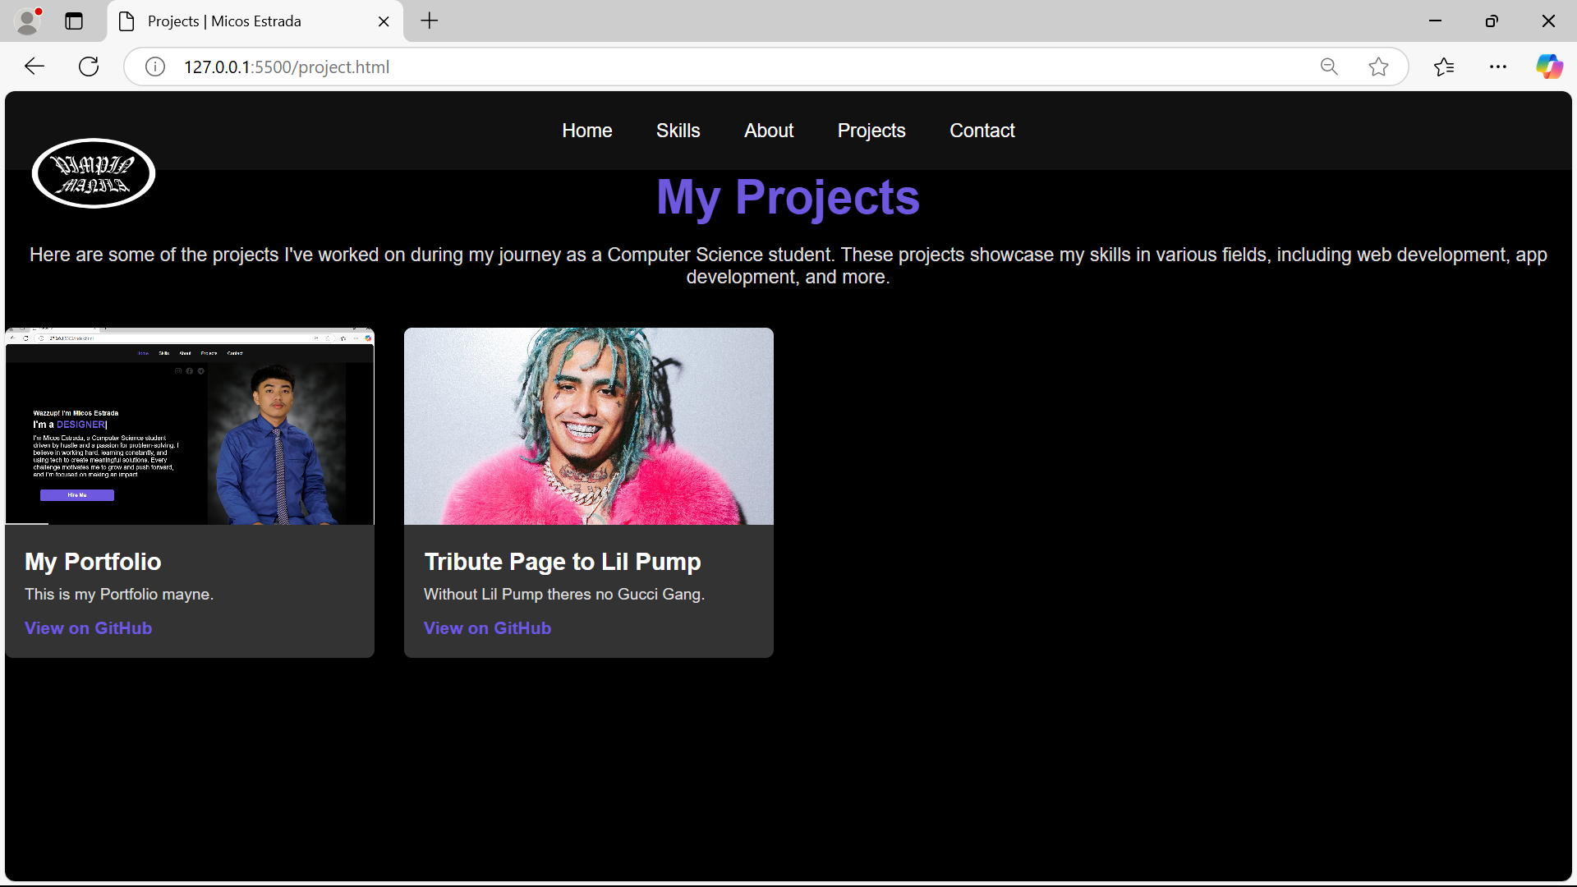

**CONTACT  
